**Topic: Comparable Interface**

**5 Interview Questions**

**1) Sorting in Ascending order with respect to experience in the Employee class.**

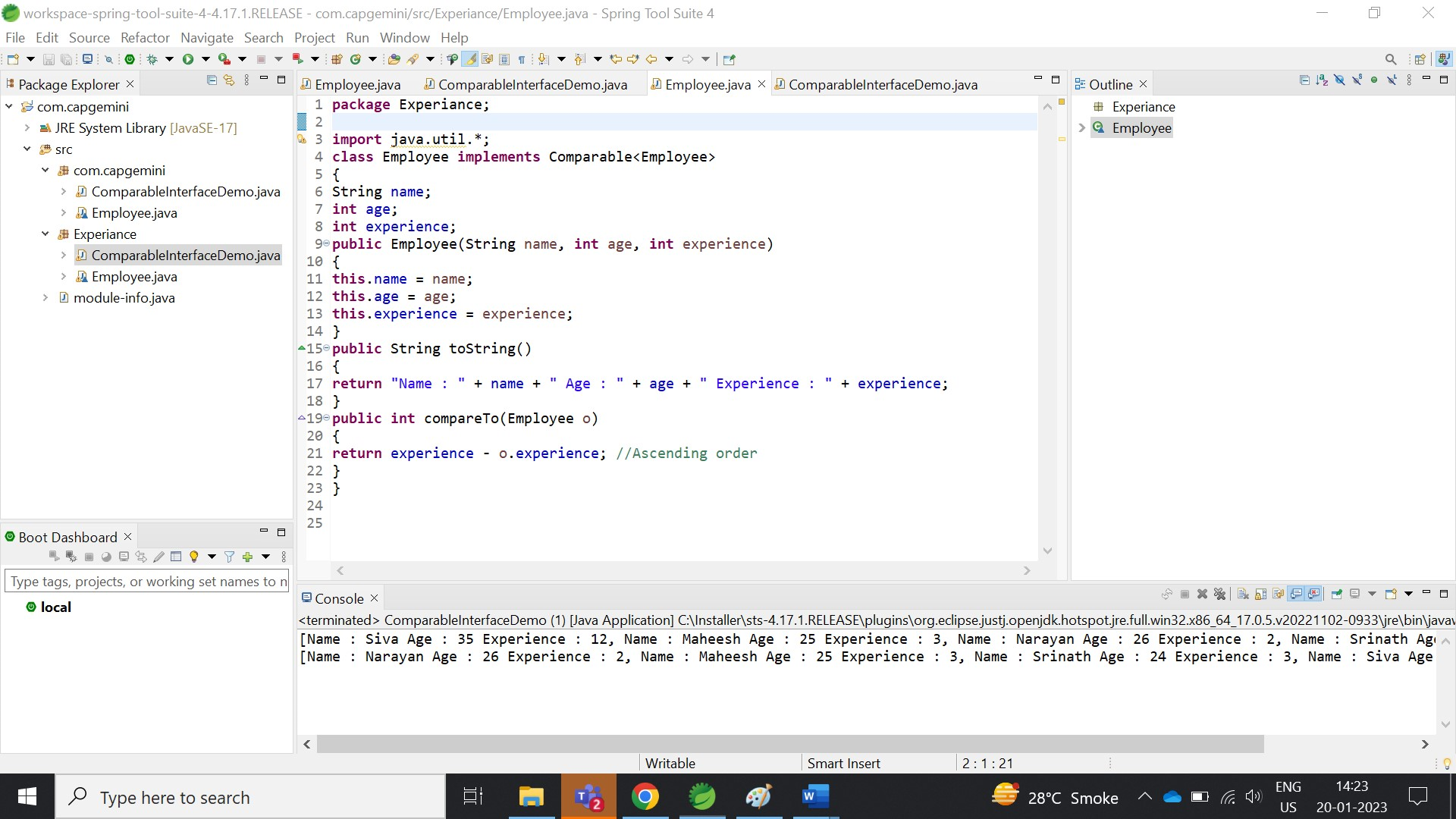

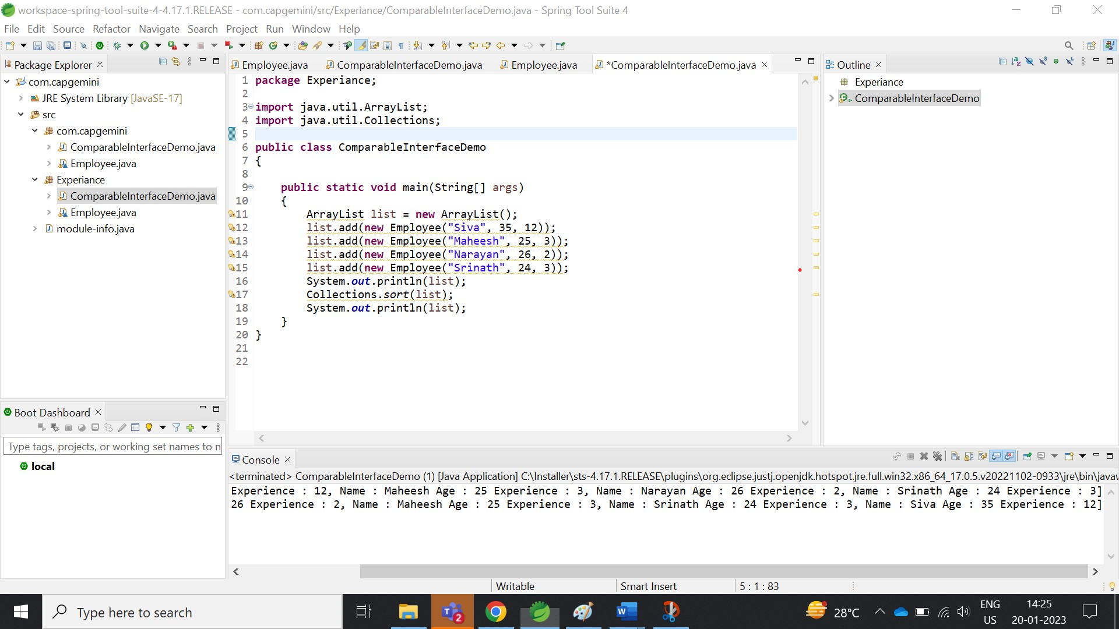

**2)** **Sorting in Descending order respect to experience in the Employee class.**

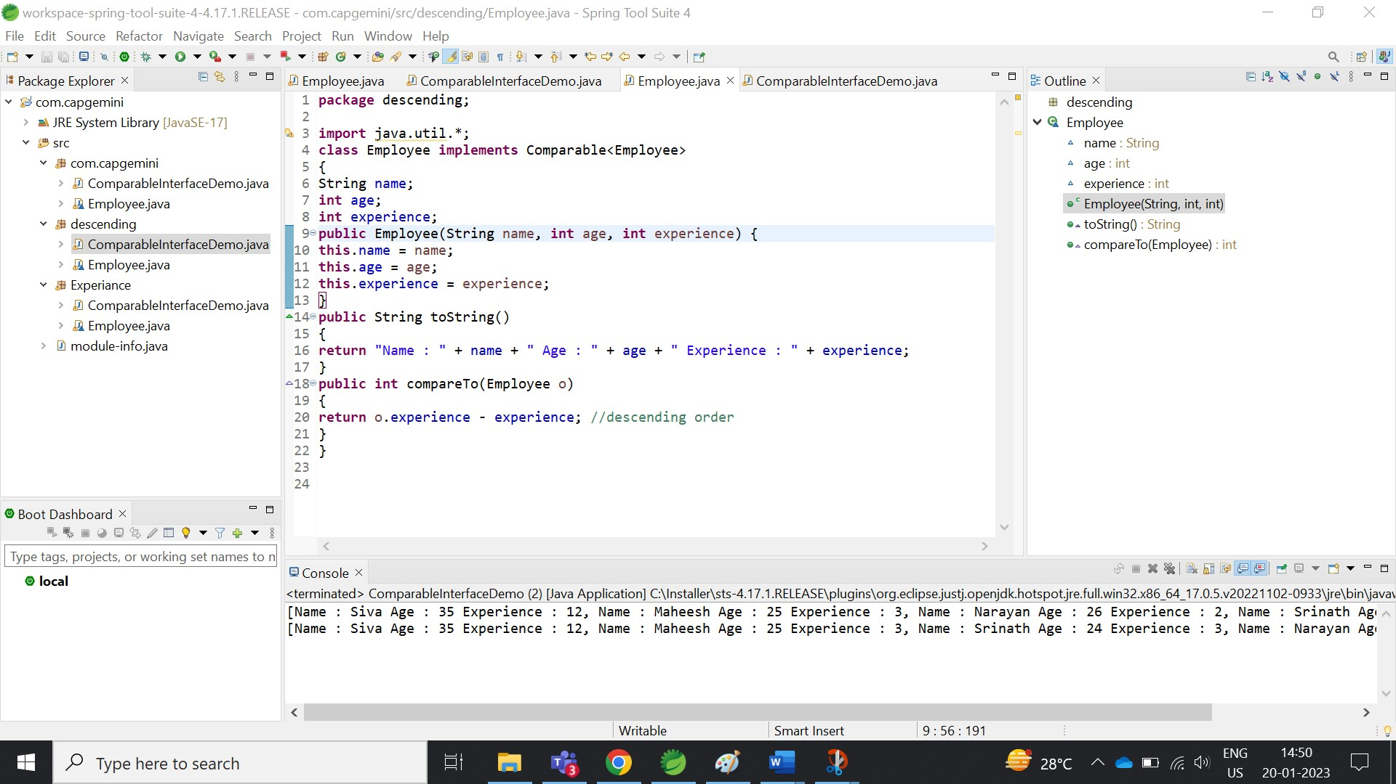

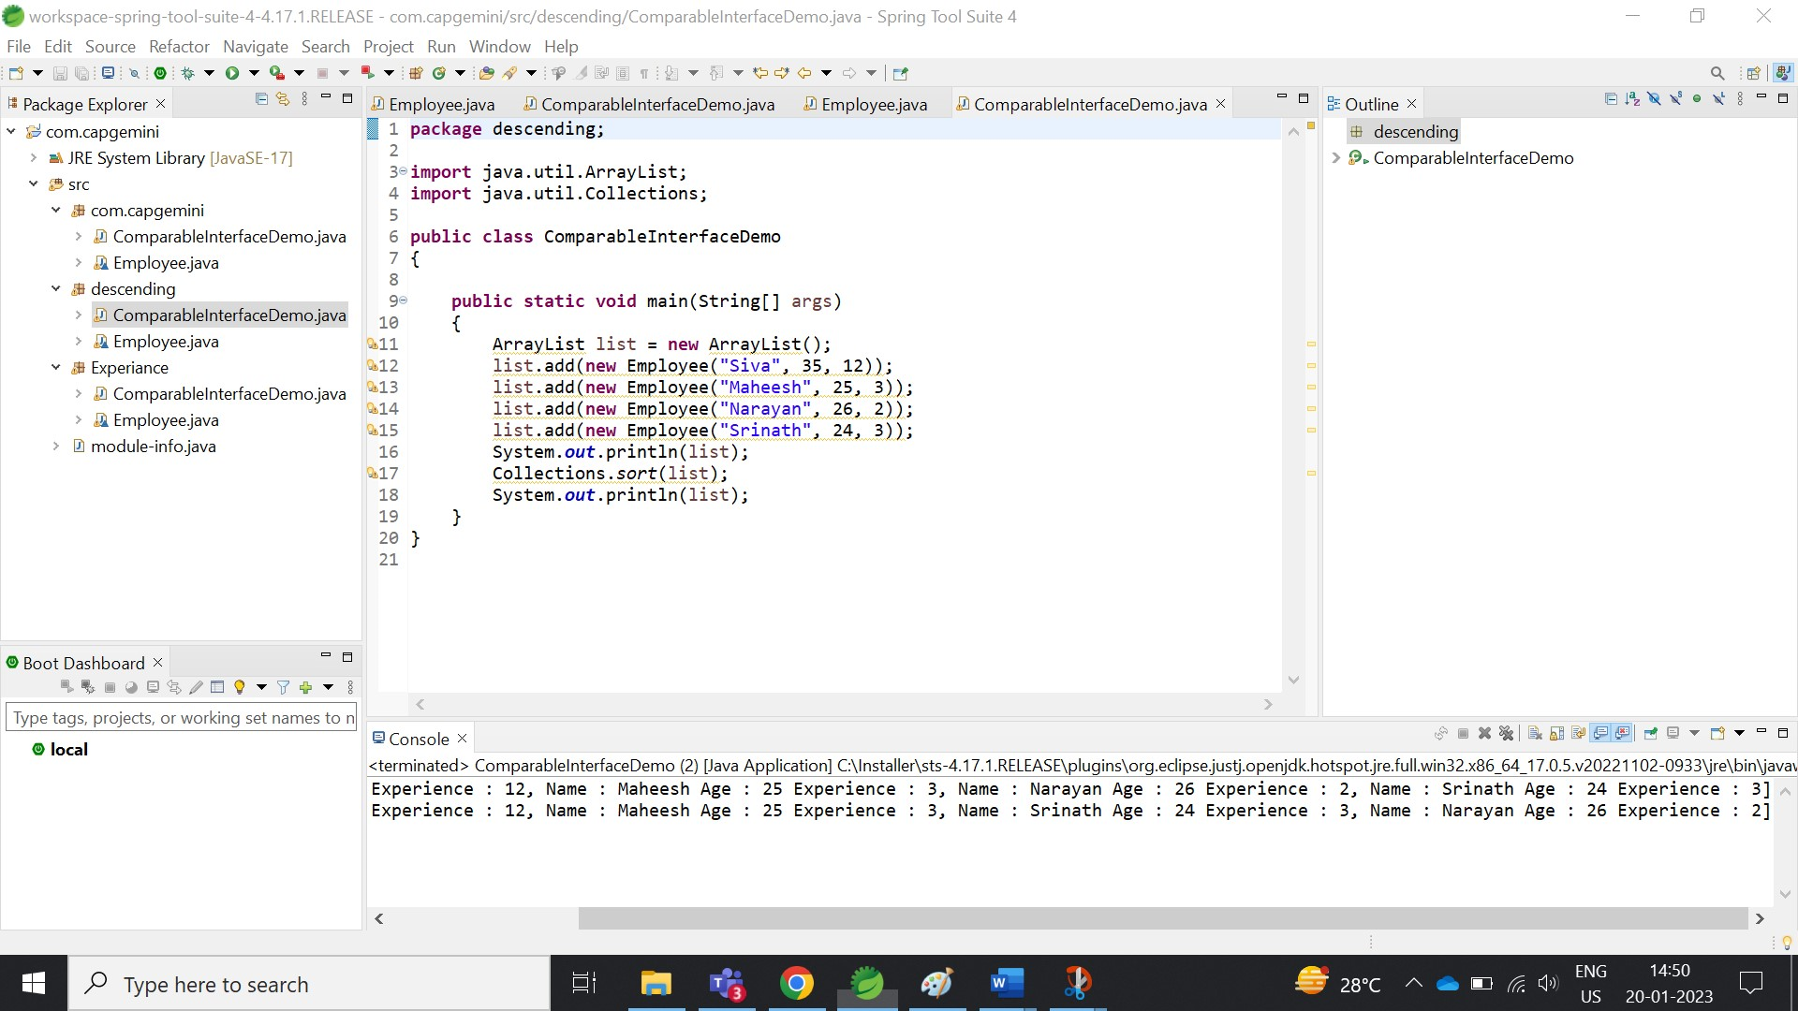

**3) Sorting in Ascending order with respect to age in the Employee Class.**

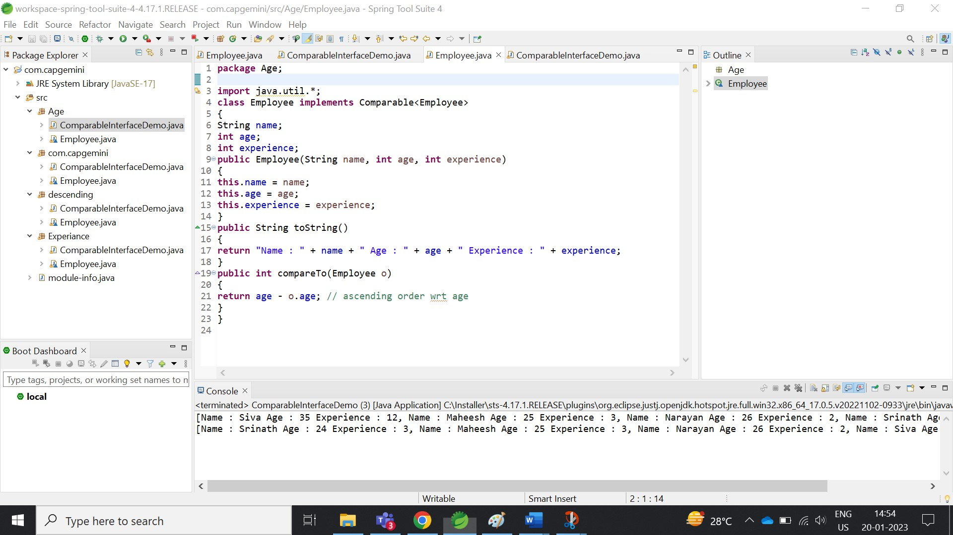

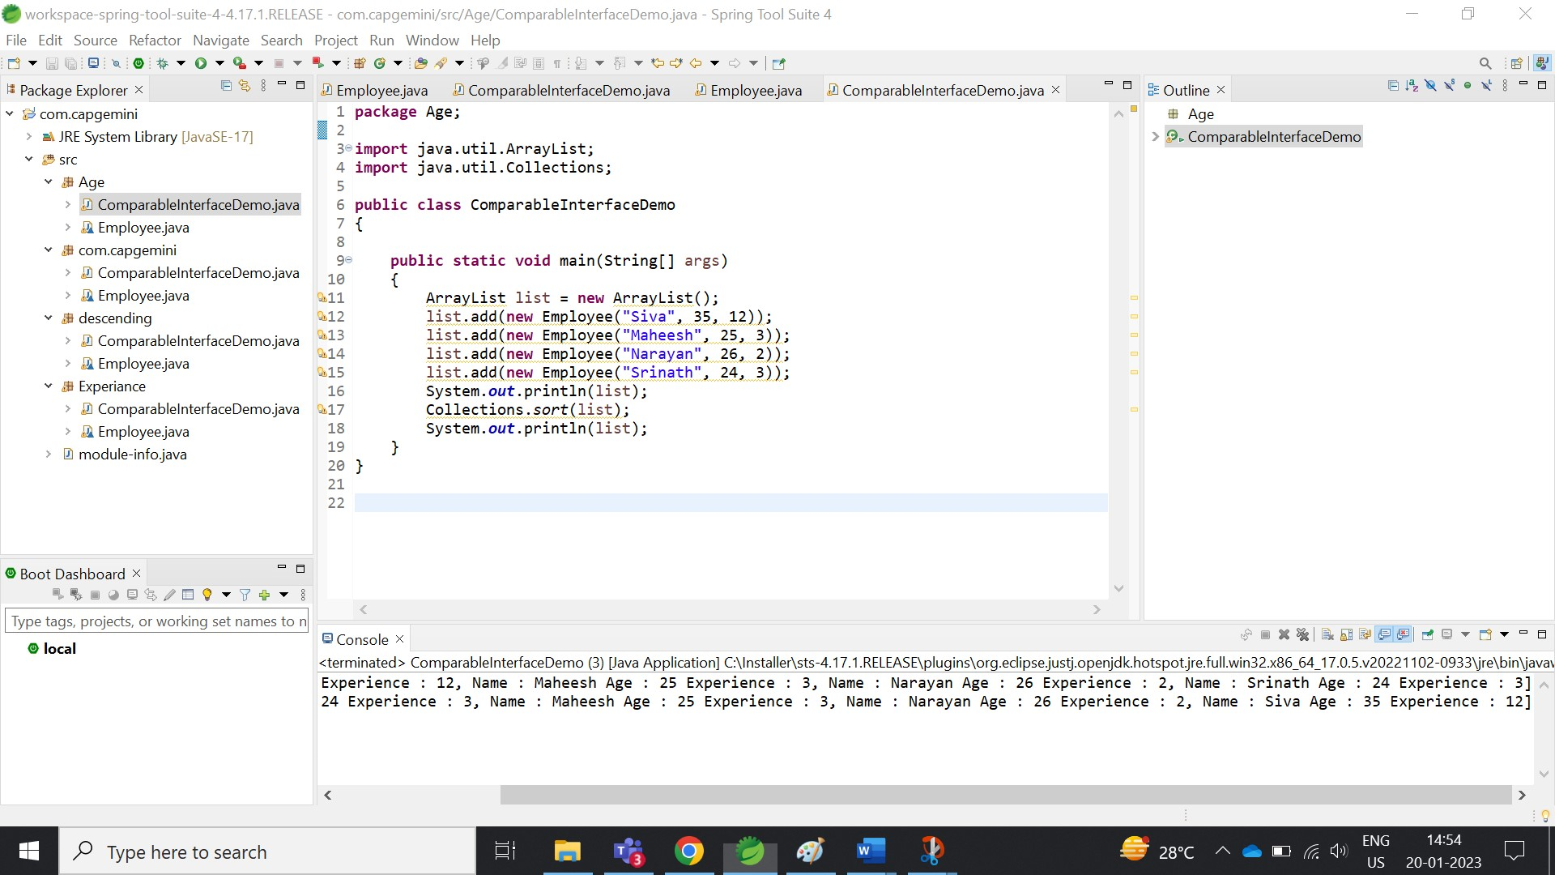

1. **Sorting in Ascending order with respect to name in the Employee Class.**

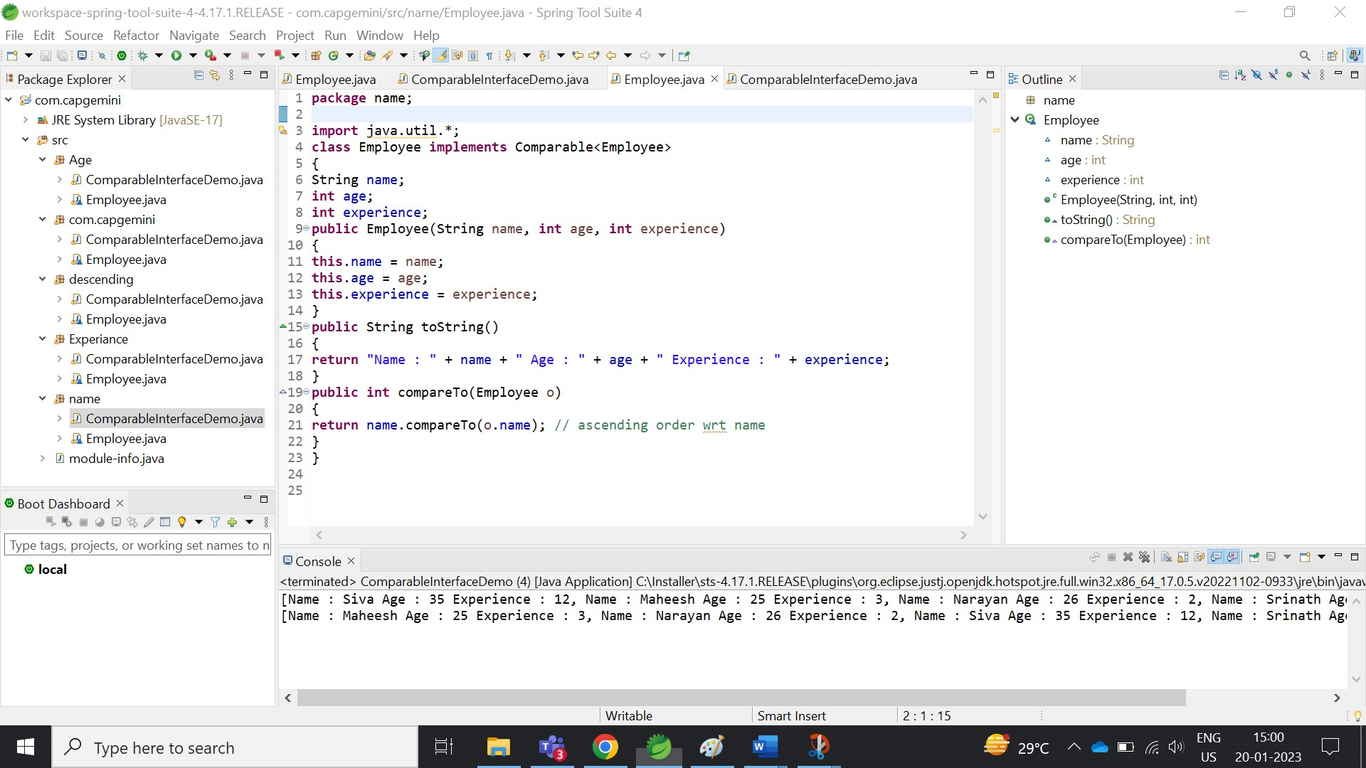

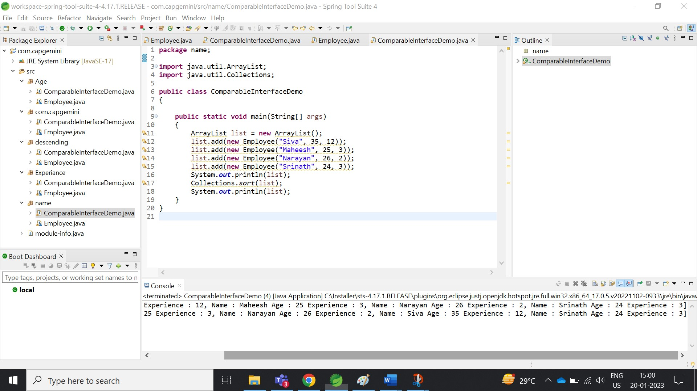

1. **Sorting in Ascending order with respect to age using if else conditional statement in the Employee Class.**

